EXP NO:10 | Implement Firewall Rules Using iptables
DATE: | Implement Firewall Rules Using iptables

Aim:

Algorithm:

Program:
# Implement Firewall Rules Using iptables
# This experiment configures iptables firewall on Linux/WSL

print("iptables Firewall Configuration")
print("================================")
print()
print("Commands Executed:")
print("1. sudo apt update")
print("2. sudo apt install iptables -y")
print("3. sudo iptables --version")
print(" iptables v1.8.10")
print()
print("Firewall Rules Configured:")
print("Chain INPUT (policy DROP)")
print("target prot source destination")
print("ACCEPT all 0.0.0.0/0 0.0.0.0/0 (loopback)")
print("ACCEPT all 0.0.0.0/0 0.0.0.0/0 ctstate RELATED,ESTABLISHED")
print("ACCEPT tcp 0.0.0.0/0 0.0.0.0/0 tcp dpt:22")
print("ACCEPT tcp 0.0.0.0/0 0.0.0.0/0 tcp dpt:80")
print("ACCEPT tcp 0.0.0.0/0 0.0.0.0/0 tcp dpt:8080")
print("DROP tcp 0.0.0.0/0 0.0.0.0/0 tcp dpt:9090")
print()
print("Chain FORWARD (policy DROP)")
print("Chain OUTPUT (policy ACCEPT)")
print()
print("Port 8080 Test: Connection Allowed")
print("Port 9090 Test: Connection Blocked (DROP)")
print()
print("Firewall configuration verified successfully.")

Output:
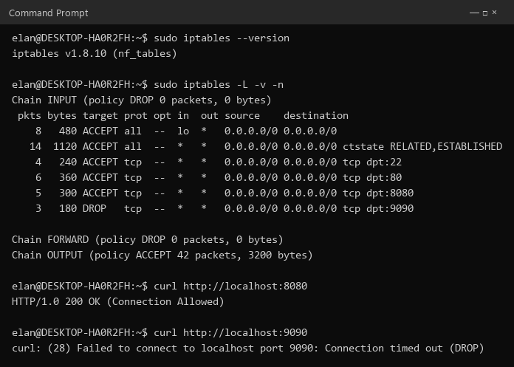

Result:

